NAME:B.Tejaswini REG NO.:192412684
COURSECODE:ECA1803

ECA1803 – OPTOELECTRONICS AND OPTICAL COMMUNICATION
CO2 PROBLEM-SOLVING ASSESSMENT
Standards-Compliant Laser Transmitter Design, Wavelength Control and Nonlinearity Management for an 8-Channel DWDM Link

Executive Summary
This report develops an engineering recommendation for an eight-channel dense wavelength-division multiplexing (DWDM) transmitter operating near 1550 nm. Each channel carries 25 Gb/s NRZ data over six amplified 80 km spans of standard single-mode fiber. The calculations show an emission wavelength of 1550 nm, internal quantum efficiency of 80%, estimated laser output power of 8.4 mW (9.24 dBm), and a required NRZ bandwidth of 17.5 GHz. A 20 GHz candidate bandwidth meets the stated estimate with a 2.5 GHz margin, although practical eye-mask and penalty testing remains necessary.
The principal recommendations are a narrow-linewidth DFB laser per channel, external modulation, thermoelectric cooler (TEC) stabilization, controlled per-channel launch power, and an integrated transmitter using a hybrid laser source with silicon-photonics routing/modulation where practical. The estimated per-span nonlinear phase shift is small (about 0.056 rad at 2 mW), but the supplied SBS estimate is below the stated launch power and therefore requires careful interpretation and verification. The given soliton parameters yield a soliton order well below one, so soliton transmission is not supported at 2 mW. Dispersion-aware DSP is preferred over relying on solitons; full eight-channel digital backpropagation may be too complex for a cost-sensitive implementation.

Assumptions and calculation conventions
- The attenuation value 0.2 dB/km is converted to a power-attenuation coefficient in nepers per kilometre before calculating effective length.
- The supplied launch power is 2 mW per channel. The total launched power for eight equal-power channels is 16 mW.
- The given laser power equation is treated as the output power of one candidate laser at the stated bias current; the 2 mW/channel figure is the power launched into the fiber after coupling, modulation and any required attenuation.
- For the simplified six-span nonlinear phase estimate, the same 2 mW power is assumed at the beginning of each span after amplification. Actual phase accumulation depends on amplifier placement, dispersion, channel interaction and phase coherence.
- The eye-safety discussion is a preliminary engineering check only. ANSI Z136 permissible exposure depends on accessible emission, wavelength, exposure duration, viewing geometry and classification; total optical power alone cannot establish compliance.
- The provided standards are considered as reference frameworks, not as proof that a 25 Gb/s-per-wavelength long-haul DWDM system is directly specified by each named standard.

Stage 1 – Interpret the Communication Requirement

1.1 System needs
- High modulation speed: 25 Gb/s NRZ requires an approximate electrical/optical bandwidth B ≈ 0.7Rb = 17.5 GHz. The transmitter should provide adequate bandwidth margin and acceptable rise/fall times.
- Narrow linewidth and high side-mode suppression: these reduce spectral overlap, wavelength uncertainty and sensitivity to filtering in the 100 GHz channel grid. Narrow linewidth also reduces susceptibility to stimulated Brillouin scattering (SBS) compared with a very narrow spectral source, although exact threshold depends on linewidth and fiber parameters.
- Adequate output power: power must cover transmitter coupling/modulator losses and provide the specified 2 mW/channel launch level without driving fiber nonlinearities excessively.
- Stable wavelength: 100 GHz spacing is approximately 0.8 nm near 1550 nm. The stated wavelength drift is large compared with the required ±0.1 nm tolerance, so active temperature control is necessary.
- Controlled chirp: chirp interacts with chromatic dispersion and can broaden pulses or close the eye over long spans. External modulation generally offers lower chirp than direct modulation.
- Nonlinear management: SPM, XPM, FWM, SBS and SRS depend on optical power, effective length, channel spacing, linewidth and fiber dispersion.
- Safety and standards: transmitter power, accessible emission, eye-safety classification, optical spectrum, extinction ratio, jitter, eye mask and interface parameters must be checked against the standards applicable to the actual product and deployment.

1.2 Standards context
ITU-T G.957 addresses optical interfaces for synchronous digital hierarchy (SDH) equipment. IEEE 802.3bm and IEEE 802.3bs address Ethernet physical-layer specifications for 100 Gb/s and 200/400 Gb/s-class systems, respectively. These documents provide useful interface and measurement concepts, but the proposed 8 × 25 Gb/s DWDM long-haul configuration is not automatically compliant simply because these standards are mentioned. The final design must identify the actual optical-interface class and use its precise wavelength, power, spectral, extinction-ratio, jitter and receiver requirements. ANSI Z136 is a laser-safety framework; a formal hazard classification and accessible-emission evaluation are required.

1.3 Problem requirement statement
The proposed transmitter must deliver eight independently modulated 25 Gb/s NRZ channels around 1550 nm on a 100 GHz grid, with stable channel wavelengths within ±0.1 nm, adequate output power and spectral purity, controlled chirp, and launch power near 2 mW per channel. It must support six amplified 80 km single-mode-fiber spans while managing Kerr and scattering nonlinearities, meeting applicable optical-interface and laser-safety requirements, and providing a practical DSP/integration strategy.

Stage 2 – Investigate and Select the Optical Source

2.1 Emission wavelength
Given: Eg = 0.80 eV. Using λ (µm) ≈ 1.24/Eg:
λ = 1.24 / 0.80 = 1.550 µm = 1550 nm.
Therefore, the calculated emission wavelength is 1550 nm, matching the intended low-loss telecom window.

2.2 Internal quantum efficiency
For radiative lifetime τr = 10 ns and non-radiative lifetime τnr = 40 ns, the internal quantum efficiency is:
ηi = (1/τr) / [(1/τr) + (1/τnr)] = τnr/(τr + τnr).
ηi = 40/(10 + 40) = 0.80 = 80%.
This idealized result means 80% of the recombination events are radiative under the simplified lifetime model. External efficiency will be lower because of extraction, coupling and other losses.

2.3 Optical-source comparison
Source | Advantages | Limitations | Suitability for this link
LED | Low cost; broad, stable emission; simple drive | Low radiance, broad spectrum and limited modulation speed | Unsuitable for long-haul 25 Gb/s DWDM
Fabry–Perot (FP) laser | Higher power and speed than LED; relatively simple | Multiple longitudinal modes and broader spectrum | Less suitable where tight DWDM spectral control is required
DBR laser | Wavelength-selective Bragg reflector; tunable designs available | More complex and potentially higher cost/control needs | Credible alternative when tunability across channels is valuable
DFB laser | Narrow linewidth, single-mode output, high speed and good fiber coupling | Temperature/current affect wavelength; needs control circuitry | Best overall choice for stable fixed-grid DWDM channels
VCSEL | Low power consumption, compact and easy array integration | Many telecom versions are optimized for shorter reaches; wavelength and power depend on design | Use only if a qualified 1550 nm long-reach version meets all link specifications
Quantum-dot (QD) laser | Potentially low threshold, temperature robustness and broad design flexibility | Commercial performance and integration depend on device implementation | Promising alternative, but qualification and standards evidence are required

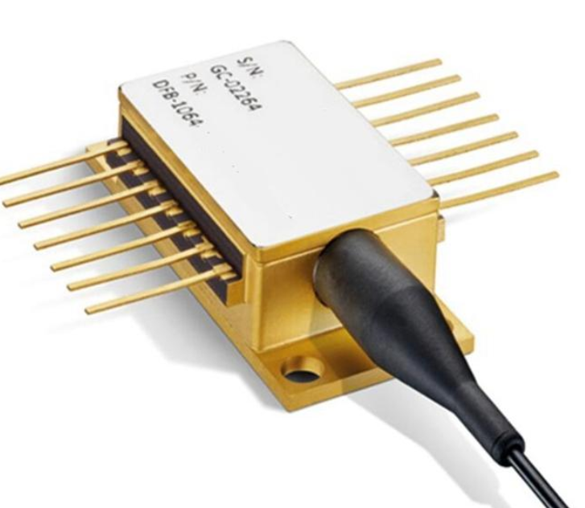

2.4 Laser operation and DWDM spectral requirements
Laser oscillation begins when round-trip modal gain equals or exceeds total round-trip loss. Below threshold, spontaneous emission dominates; above threshold, stimulated emission produces coherent laser output. A narrow optical linewidth limits spectral spreading, while high side-mode suppression ratio (SMSR) reduces unwanted power in neighboring longitudinal modes. In a 100 GHz DWDM grid, unwanted modes or wavelength drift can pass through adjacent filters and increase crosstalk.

Design Decision 1 – Select the optical source
I recommend DFB laser sources because they offer single-longitudinal-mode emission, narrow linewidth, high modulation capability, good fiber coupling and practical availability near 1550 nm. The calculated 1550 nm wavelength matches the operating window, and the system requires a stable wavelength grid over long amplified spans.
A credible alternative is a tunable DBR laser. It becomes preferable when dynamic wavelength assignment, wavelength reconfiguration or spare-channel flexibility is a major system requirement and its tuning range, linewidth, output power and control performance are qualified.

Stage 3 – Modulation, Chirp and Spectral Stability

3.1 Output power at stated bias
Given slope efficiency ηs = 0.3 mW/mA, threshold current Ith = 12 mA and bias I = 40 mA:
P = ηs(I − Ith) = 0.3 × (40 − 12) = 8.4 mW.
P(dBm) = 10 log10(P[mW]) = 10 log10(8.4) = 9.24 dBm.
The estimated laser output is 8.4 mW (9.24 dBm). This is the laser-output estimate, not necessarily the power launched into the fiber; modulator, coupling, mux and connector losses must be included in a real power budget.

3.2 Modulation bandwidth
For Rb = 25 Gb/s and B ≈ 0.7Rb:
Brequired ≈ 0.7 × 25 = 17.5 GHz.
Candidate bandwidth = 20 GHz. Margin = 20 − 17.5 = 2.5 GHz, or 14.3% of the estimated requirement.
The 20 GHz candidate is sufficient under the supplied approximate rule. The 2.5 GHz margin is not large; the complete transmitter must still be verified for extinction ratio, rise/fall time, eye opening, driver bandwidth, modulator response and implementation penalties.

3.3 Carrier and photon rate equations
A common simplified semiconductor-laser rate-equation model is:
dN/dt = I/(qV) − N/τn − Γ vg g(N,S) S
dS/dt = Γ βsp N/τsp + Γ vg g(N,S) S − S/τp
where N is carrier density, S is photon density, I is injection current, q is electron charge, V is active-region volume, τn is carrier lifetime, Γ is optical confinement factor, vg is group velocity, g is material gain, βsp is the spontaneous-emission coupling factor and τp is photon lifetime. The relaxation-oscillation frequency is the characteristic resonance of coupled carrier–photon dynamics around the steady operating point; its exact numerical value cannot be calculated from the supplied data alone because differential gain, photon lifetime, confinement and operating-point parameters are not given.
Small-signal modulation is a perturbation around the bias point and is commonly described by a frequency response with a relaxation-oscillation peak. Large-signal modulation causes larger carrier and photon excursions, nonlinear gain dynamics, pattern effects and potentially greater chirp; it cannot be fully predicted by a small-signal bandwidth number alone.

3.4 Direct versus external modulation
Aspect | Direct modulation | External modulation
Method | Modulate laser injection current | Keep laser near steady output; modulate with an external device such as an MZM or EAM
Chirp | Usually higher due to carrier-induced refractive-index changes | Can be low with a properly biased Mach–Zehnder modulator
Bandwidth | Limited by laser/driver dynamics | Can support high speed if modulator and driver bandwidth are adequate
Dispersion interaction | Chirp can combine with dispersion and degrade eye opening | Lower chirp can improve reach and dispersion tolerance
Complexity/power | Potentially simpler and lower cost | More components, bias control and insertion loss
Recommendation | Good for shorter/less demanding links | Preferred for the six-span DWDM link

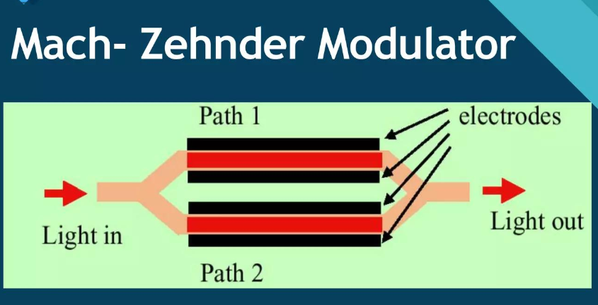

3.5 Temperature drift and wavelength control
Given wavelength drift = 0.1 nm/°C and ambient change = 40 °C:
Uncontrolled drift = 0.1 × 40 = 4.0 nm.
Relative to the 0.8 nm channel spacing, 4.0/0.8 = 5.0 channel spacings.
This drift is five times the channel spacing and is unacceptable for the fixed-grid DWDM transmitter. To maintain ±0.1 nm wavelength tolerance, the temperature deviation must be limited to ±(0.1 nm)/(0.1 nm/°C) = ±1 °C, assuming the stated linear coefficient.
A TEC with a thermistor/temperature sensor and closed-loop controller is recommended. Injection-current tuning is useful for fine adjustment, but current also changes output power, chirp and device temperature. Current tuning should therefore be limited to calibrated fine control rather than used as the only method for rejecting a 40 °C ambient variation.

Design Decision 2 – Modulation and wavelength control
I recommend external Mach–Zehnder modulation and TEC-based wavelength control, with calibrated current control for fine tuning. The 20 GHz bandwidth exceeds the estimated 17.5 GHz requirement by 2.5 GHz, while external modulation reduces chirp-related penalties over the multi-span link. TEC regulation to approximately ±1 °C is required to support the stated ±0.1 nm wavelength tolerance.

Stage 4 – Investigate and Control Optical Nonlinearities

4.1 Effective length
The attenuation is α = 0.2 dB/km. Convert to nepers/km: αNp = 0.2/4.343 = 0.04605 km⁻¹.
For L = 80 km:
Leff = [1 − exp(−αL)]/α = [1 − exp(−0.04605 × 80)]/0.04605 = 21.17 km.

4.2 Self-phase modulation (SPM)
Given nonlinear coefficient γ = 1.3 W⁻¹km⁻¹ and per-channel power P = 2 mW = 0.002 W:
φNL,span = γ P Leff = 1.3 × 0.002 × 21.17 = 0.0550 rad per span.
Six-span simplified estimate: 6 × 0.0550 = 0.330 rad.
This is a simplified upper-level bookkeeping estimate with the same power reset at each amplified span. The actual phase and waveform distortion depend on dispersion, amplifier noise, pulse shape and how the nonlinear phase evolves along the link.

4.3 XPM and FWM
- Cross-phase modulation (XPM): the intensity of one WDM channel changes the nonlinear phase of neighboring channels. Its impact rises with channel power and overlap in time; dispersion and walk-off can reduce or redistribute the interaction.
- Four-wave mixing (FWM): the Kerr effect mixes optical frequencies and can create new components at combinations such as fi + fj − fk. Generated components are especially troublesome when they fall on an occupied channel. Phase matching depends on fiber dispersion and channel-frequency spacing; 100 GHz spacing and nonzero dispersion influence the efficiency.
- Practical controls include limiting launch power to the optimized operating point, using suitable fiber with appropriate dispersion, maintaining accurate channel spacing and equalization, and applying receiver DSP where justified.
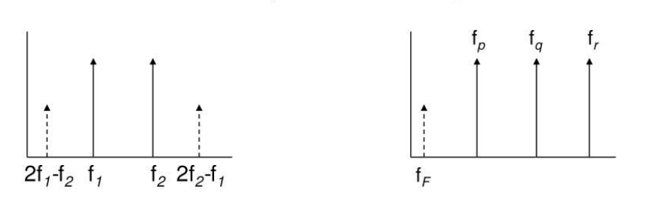

4.4 SBS and SRS threshold estimates
Use Aeff = 80 µm² = 80 × 10⁻¹² m² and Leff = 21.7 km = 21,700 m.
SBS: Pth ≈ 21 Aeff/(gB Leff) = 21 × 80×10⁻¹² / (5×10⁻¹¹ × 21170) = 0.001587 W = 1.59 mW.
SRS: Pth ≈ 16 Aeff/(gR Leff) = 16 × 80×10⁻¹² / (6×10⁻¹⁴ × 21170) = 1.008 W.
Quantity | Calculated/assumed value | Comparison
Per-channel launch power | 2 mW | About 1.29 times the simplified SBS estimate; far below the SRS estimate
Total launch power (8 channels) | 16 mW | Still far below the calculated SRS threshold; total-power comparison with SBS is not a direct single-channel threshold test
Simplified SBS threshold | 1.59 mW | The supplied formula flags SBS as a potential concern requiring verification
Simplified SRS threshold | 1.008 W | Much higher than 16 mW under the given model

Important qualification: the supplied threshold formula is highly simplified. SBS depends on linewidth, polarization, fiber details, effective interaction length and modulation. The computed value should be treated as a screening estimate, not a final physical guarantee. A broader effective optical linewidth generally raises the SBS threshold; a narrow-linewidth laser can be more susceptible.

4.5 SBS versus SRS
Feature | SBS | SRS
Physical origin | Interaction with acoustic phonons; predominantly backward scattering in standard fiber | Interaction with optical phonons; energy can transfer from higher-frequency to lower-frequency light
Gain bandwidth | Narrow | Much broader
Power transfer | Can reflect significant power backward and destabilize the transmitter/link | Can transfer power between WDM channels and create tilt/depletion
DWDM implication | Narrow-linewidth high-power channels may approach threshold | Inter-channel Raman transfer grows with aggregate power and distance
Mitigation | Reduce per-channel power where necessary; broaden/modulate linewidth where compatible; verify thresholds | Manage aggregate launch power, channel power balance and span design

4.6 Eye-safety check
Total launched power = 8 × 2 mW = 16 mW. For an illustrative conservative screening assumption of a 10 mW accessible-emission limit, 16 mW would exceed the assumed limit. This is not a claim that ANSI Z136 universally sets a 10 mW limit: actual permissible exposure and classification depend on wavelength, exposure time, accessible geometry and the product's laser class. The design must use enclosed fiber connectors, appropriate interlocks/labels, service procedures and a formal accessible-emission evaluation.

4.7 Nonlinear-control strategy
I recommend controlled launch power and channel equalization, dispersion-aware link engineering, SBS verification using the actual modulated linewidth, and receiver DSP for residual impairments. Two practical methods that avoid unnecessarily reducing received signal are (1) optimize the launch power and amplifier gain per span rather than simply maximizing power, and (2) use dispersion-aware receiver equalization/DSP and channel-power balancing. If SBS measurements indicate inadequate margin, consider a compatible linewidth-broadening or phase-dither technique.

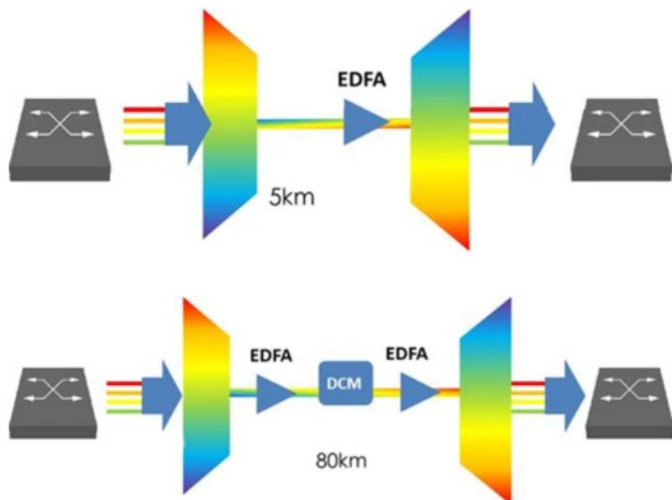

Design Decision 3 – Nonlinearity control
I recommend a power-managed DWDM link with span-by-span gain equalization, actual-linewidth SBS testing, suitable dispersion and channel-power balancing, plus receiver DSP. The calculated SPM phase is approximately 0.056 rad per span at 2 mW, while the simplified SBS estimate is approximately 1.55 mW and thus warrants validation. The SRS estimate is about 0.98 W, well above the 16 mW total launch power in this simplified model.

Stage 5 – Soliton, Digital Backpropagation and Integration

5.1 Soliton condition and dispersion length
Soliton transmission relies on a balance between anomalous chromatic dispersion and Kerr nonlinearity. For the supplied pulse parameter T0 = 15 ps and |β2| = 20 ps²/km:
LD = T0²/|β2| = (15 ps)²/(20 ps²/km) = 11.25 km.
For a fundamental soliton, N = 1 and LD = LNL = 1/(γP0). Therefore:
Pfundamental = 1/(γ LD) = 1/(1.3 × 11.25) = 0.0684 W = 68.4 mW.
This simplified fundamental-soliton power is substantially greater than the stated 2 mW per-channel launch power.

5.2 Nonlinear length and soliton order at 2 mW
LNL = 1/(γP0) = 1/(1.3 × 0.002) = 384.6 km.
N² = LD/LNL = 11.25/384.6 = 0.02925; N = √(LD/LNL) = 0.171.
Since N ≈ 0.17, the specified pulse and launch power do not meet the fundamental-soliton condition (N = 1). Soliton transmission is therefore not feasible under the stated 2 mW conditions without changing the pulse peak power and/or other system parameters. Raising power simply to reach the soliton value would need a new nonlinear and safety analysis.

5.3 Digital backpropagation
Digital backpropagation (DBP) numerically approximates inverse propagation through a model of chromatic dispersion and Kerr nonlinearity. It can mitigate SPM and some XPM effects when the signal bandwidth, channel interaction and link model are represented accurately. Limitations include computational complexity, sensitivity to model mismatch, amplified spontaneous-emission noise that cannot be inverted, and the need to sample/process a sufficiently wide bandwidth.
For the complete eight-channel link, full multi-channel DBP is technically possible in principle but may be costly in computation and power. A practical baseline is electronic chromatic-dispersion compensation plus equalization and suitable per-channel DSP. Multi-channel DBP should be selected only if measured nonlinear penalties justify its complexity and the receiver can process the relevant aggregate bandwidth.

5.4 Standards verification plan
- Confirm the exact interface category and applicable revision before claiming compliance. ITU-T G.957 is an SDH optical-interface reference; IEEE 802.3bm and 802.3bs define particular Ethernet PHY interfaces rather than a blanket requirement for this custom DWDM line system.
- Measure central wavelength and wavelength drift for every channel over the specified ambient range; verify channel spacing and spectral mask against the selected interface specification.
- Measure average launch/output power, power variation, extinction ratio, optical spectrum/SMSR, transmitter eye diagram, jitter and modulation bandwidth using the relevant test method.
- Perform receiver-sensitivity/BER testing across the complete link, including amplifier noise, dispersion, nonlinear effects and connector/coupling losses.
- Complete formal laser classification and accessible-emission assessment under the applicable ANSI Z136 edition and local safety rules.

5.5 Integration alternatives
Implementation | Benefits | Trade-offs | Assessment
Discrete components | Flexible component selection, straightforward replacement and debugging | Larger footprint, more fiber connections, coupling loss and assembly variation | Useful for laboratory prototype or low-volume system
Monolithic InP integration | Can integrate laser, modulator and photonic functions on one material platform; compact optical path | Thermal/crosstalk management, process complexity, yield and design flexibility constraints | Strong option for tightly integrated telecom transmitter arrays
Silicon photonics with hybrid laser | Scalable passive routing, muxing and modulators; mature silicon processing; laser can be selected separately | Hybrid laser coupling, packaging alignment, thermal control and reliability qualification remain important | Recommended balance for a scalable 8-channel transmitter if qualified parts are available

Design Decision 4 – Integrated transmitter implementation
I recommend a silicon-photonics transmitter PIC with hybrid-integrated narrow-linewidth DFB lasers, external modulators, wavelength muxing and TEC/monitor feedback. This approach supports compact routing and scalable multi-channel integration while retaining a laser technology with suitable 1550 nm spectral properties. Use chromatic-dispersion compensation and per-channel DSP as the baseline; reserve full multi-channel DBP for cases where link measurements show sufficient benefit.
Stage 6 – Verify and Critically Evaluate the Complete Solution
Requirement | Target / calculation | Achieved? / evaluation
Optical source | DFB laser per channel; 1550 nm; narrow linewidth and high SMSR | Conditionally satisfactory; final device datasheet and spectrum tests required
Output power | 8.4 mW estimated laser output = 9.24 dBm; fiber launch set to 2 mW/channel | Satisfactory as a preliminary budget; verify insertion/coupling losses
Modulation bandwidth | 17.5 GHz required; candidate 20 GHz | Satisfactory under B ≈ 0.7Rb, with 2.5 GHz margin; validate eye and BER
Wavelength stability | ±0.1 nm; stated drift 0.1 nm/°C | Requires TEC feedback maintaining approximately ±1 °C equivalent stability
Nonlinear control | SPM ≈ 0.056 rad/span; SBS simplified threshold ≈ 1.55 mW; SRS ≈ 0.98 W | SPM estimate modest; SBS margin is not demonstrated and must be tested with actual linewidth
Eye safety | Total launch = 16 mW | Not proven from power alone; formal ANSI Z136 accessible-emission/classification check required
Soliton / dispersion | LD = 11.25 km; LNL = 384.6 km; N ≈ 0.17 | Soliton transmission not supported at the stated launch power
DSP / integration / standards | Hybrid-laser silicon photonics; dispersion compensation and receiver DSP; standards test plan | Plausible design direction; compliance depends on selecting the correct interface specification and test results

Overall verification: the proposed design is consistent with the main wavelength, data-rate and transmitter-control requirements at a preliminary design level. It is not ready for deployment until wavelength stability, actual optical spectrum, launch-power budget, SBS behaviour, eye safety, and end-to-end BER are measured and the applicable interface standard is selected.
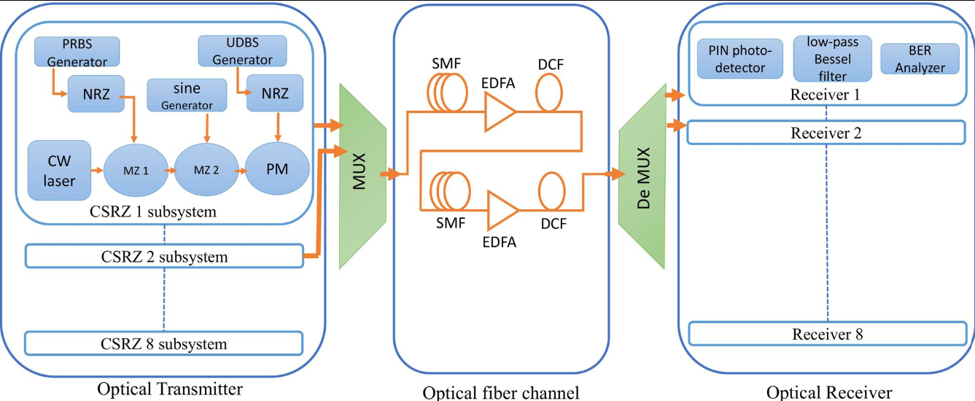

Final Transmitter Design – Integrated Engineering Solution

Final parameter/design table
Parameter | Adopted design / calculated value | Reason
Number of channels | 8 | Specified DWDM configuration
Channel spacing | 100 GHz (approximately 0.8 nm) | Fixed-grid wavelength separation
Nominal wavelength | 1550 nm | From Eg = 0.80 eV and telecom window
Data rate | 25 Gb/s NRZ per channel | Specified rate
Optical source | Narrow-linewidth DFB laser per channel | Single-mode spectral quality and high-speed suitability
Estimated laser output | 8.4 mW; 9.24 dBm per laser | From slope-efficiency equation at 40 mA
Laser bias | 40 mA; threshold 12 mA | Specified operating data
Modulation | External Mach–Zehnder modulator | Reduced chirp for long multi-span link
Bandwidth | 20 GHz candidate vs 17.5 GHz estimated requirement | 2.5 GHz nominal margin
Wavelength control | TEC feedback; equivalent stability about ±1 °C; current tuning for fine trim | Meets ±0.1 nm target under given drift coefficient
Fiber launch power | 2 mW/channel; 16 mW aggregate | Given condition; set after accounting for transmitter losses
Effective length | 21.7 km per 80 km span | Attenuation converted from dB/km to nepers/km
SPM phase estimate | 0.056 rad/span; 0.338 rad over six spans (simplified) | Nonlinear screening estimate
SBS / SRS estimates | 1.55 mW / 0.98 W | Simplified formula results; SBS needs real-system validation
Soliton metrics | LD = 11.25 km; Pfundamental ≈ 68.4 mW; N ≈ 0.17 at 2 mW | Soliton condition not met at stated power
Integration | Silicon photonics with hybrid DFB lasers | Compact routing and scalable 8-channel integration
Compensation | Chromatic-dispersion compensation and receiver DSP; DBP only if justified | Practical balance of performance and complexity

Block diagram of proposed DWDM transmitter and link
Channel 1 data/driver → DFB laser 1 → external MZM 1 ┐
Channel 2 data/driver → DFB laser 2 → external MZM 2 ├─→ 8-channel AWG/mux
... │
Channel 8 data/driver → DFB laser 8 → external MZM 8 ┘
↑ TEC + wavelength monitor/control for each laser
↓
output monitor / safety interlock
↓
launch-power control / line amplifier (as required)
↓
80 km SMF → amplifier → 80 km SMF → amplifier → ... (6 spans)
↓
receiver demux → photodetectors → DSP / BER check
Note: In an integrated implementation, the DFB laser array may be hybrid-attached to a silicon-photonics PIC containing modulators, waveguides, monitor taps and an arrayed-waveguide-grating (AWG) multiplexer. The line amplifier placement depends on the system power budget.

Final engineering recommendation
The recommended solution is an eight-channel transmitter based on narrow-linewidth DFB lasers, external Mach–Zehnder modulation, TEC wavelength stabilization, integrated wavelength multiplexing and controlled launch power. Use a hybrid laser/silicon-photonics implementation where component qualification and packaging yield support it. Use receiver dispersion compensation and DSP as the default impairment-management approach; do not rely on soliton propagation because the calculated soliton order at 2 mW is only about 0.17. Test SBS under the actual modulated linewidth and channel loading because the simplified SBS threshold estimate is below the nominal per-channel launch power. Apply formal eye-safety classification and verify the precise interface standard before claiming compliance.

Final engineering decision: WOULD YOU DEPLOY IT?
NO – not immediately as a production system. YES as a design candidate for prototype and qualification testing. The calculations support the wavelength and approximate bandwidth requirement, and the architecture is technically plausible. However, deployment must wait until the actual SBS margin, optical spectrum, temperature stability, insertion-loss/power budget, end-to-end BER, receiver performance, applicable standards compliance and ANSI Z136 safety classification have been verified experimentally.

Conclusion
The study selects DFB lasers with external modulation and TEC control for the eight-channel 1550 nm DWDM transmitter. The output-power calculation gives 8.4 mW, and the candidate 20 GHz bandwidth exceeds the estimated 17.5 GHz requirement. Uncontrolled thermal drift would be 4 nm, so active wavelength stabilization is essential. The simplified nonlinear calculations show modest SPM phase but identify SBS as a potential issue requiring real-device validation. The soliton order is below one, so soliton operation is not feasible at the stated power. A hybrid-laser silicon-photonics implementation with dispersion compensation and receiver DSP is recommended, subject to standards, safety and end-to-end performance testing.

References / technical basis
- Assignment brief: ECA18 – Optoelectronics and Optical Communication, CO2 Problem-Solving Assignment, supplied parameter set and six-stage assessment requirements.
- ITU-T G.957: Optical interfaces for equipment and systems relating to the synchronous digital hierarchy (SDH).
- IEEE 802.3bm and IEEE 802.3bs: Ethernet physical-layer specifications (consult the applicable edition and interface clause for compliance testing).
- ANSI Z136 series: Safe use of lasers; consult the applicable edition and product-specific laser-safety classification procedure.
Submission note: Replace the student information blanks and confirm the exact standard editions/interface class specified by your instructor.

